A000-Asia-Japan-Haniwa-Female Scribal Figure-Kofun Period-250 to 538 CE

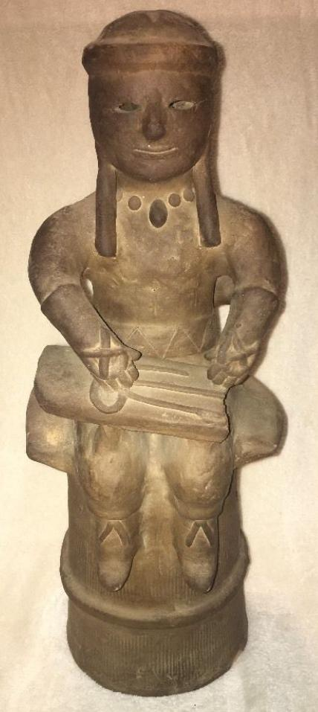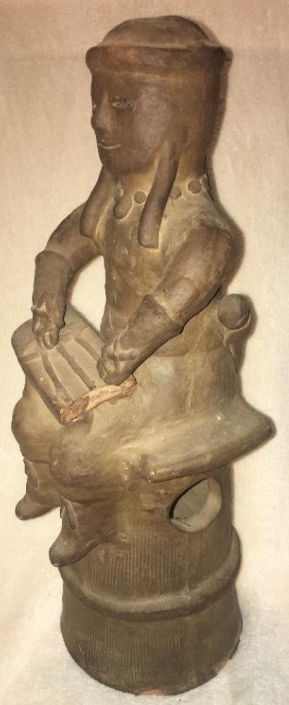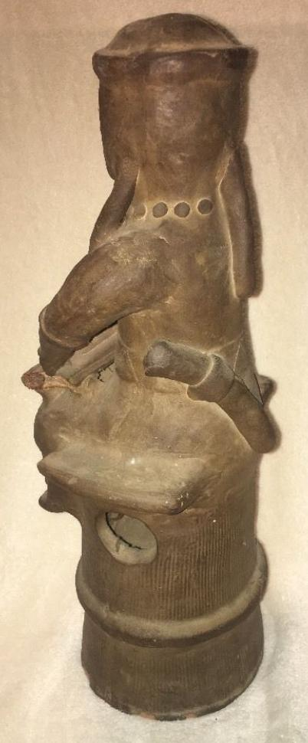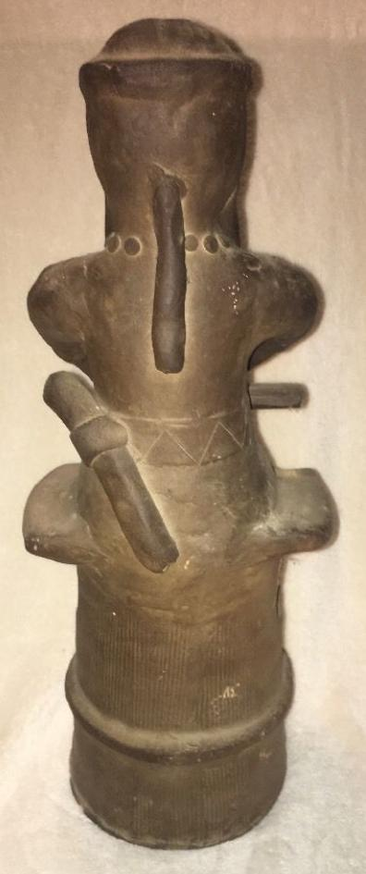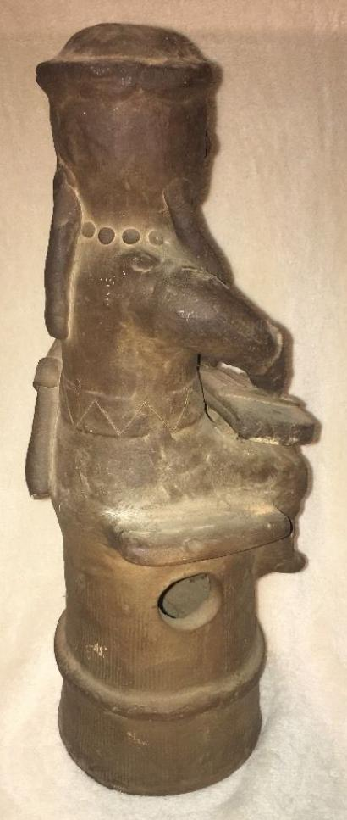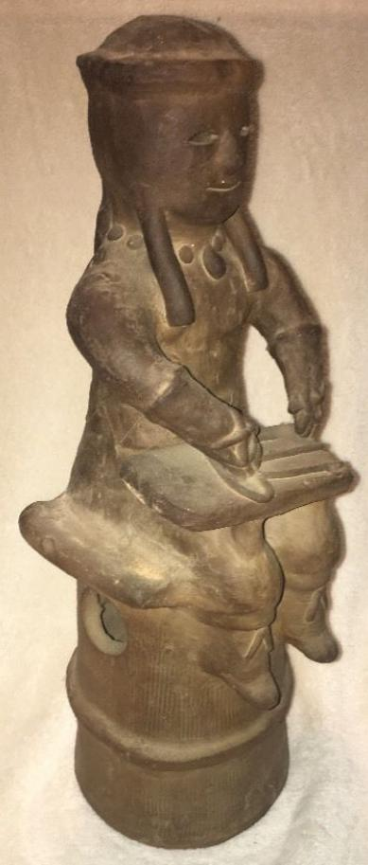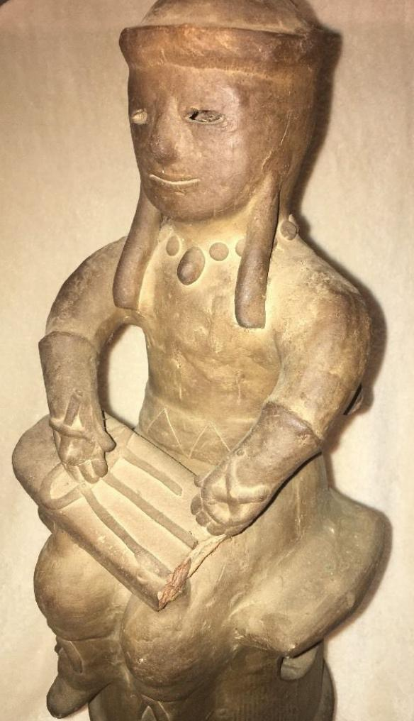

Formal Label: Dis-Asia-Japan-Haniwa-Scribal Figure-Kofun Period-250 to 538 AD-CE

Accession Number: NB 1667.A3

Date or Time Horizon: 250 to 538 AD-CE

Geographical Area: Japan

Cultural Affiliation: Kofun Period

Medium: Terracotta

Dimensions: 16.5 in

Weight:

Provenance: U.S. Naval Captain, Occupied Japan, 1947.

**Condition:** Missing piece on scribal plaque.